# Software Testing

**Software Testing:**

* Software Testing is a method to check whether the actual software product matches expected requirements and to ensure that software product is defect free
* The purpose of software testing is to identify errors, gaps or missing requirements in contrast to actual requirements.



**Importance and Benefits of Software Testing:**

* If there are any bugs or errors in the software, it can be identified early and can be solved before delivery of the software product.
* It ensures reliability, security and high performance
* Also leads to time saving, cost effectiveness and customer satisfaction

**Types of Software Testing:**

1. **Unit Testing:**

* In Unit Testing, individual units or components of a software are tested. The purpose is to validate that each unit of the software code performs as expected
* Unit Tests isolate a section of code and verify its correctness
* A unit may be an individual function, method, procedure, module, or object

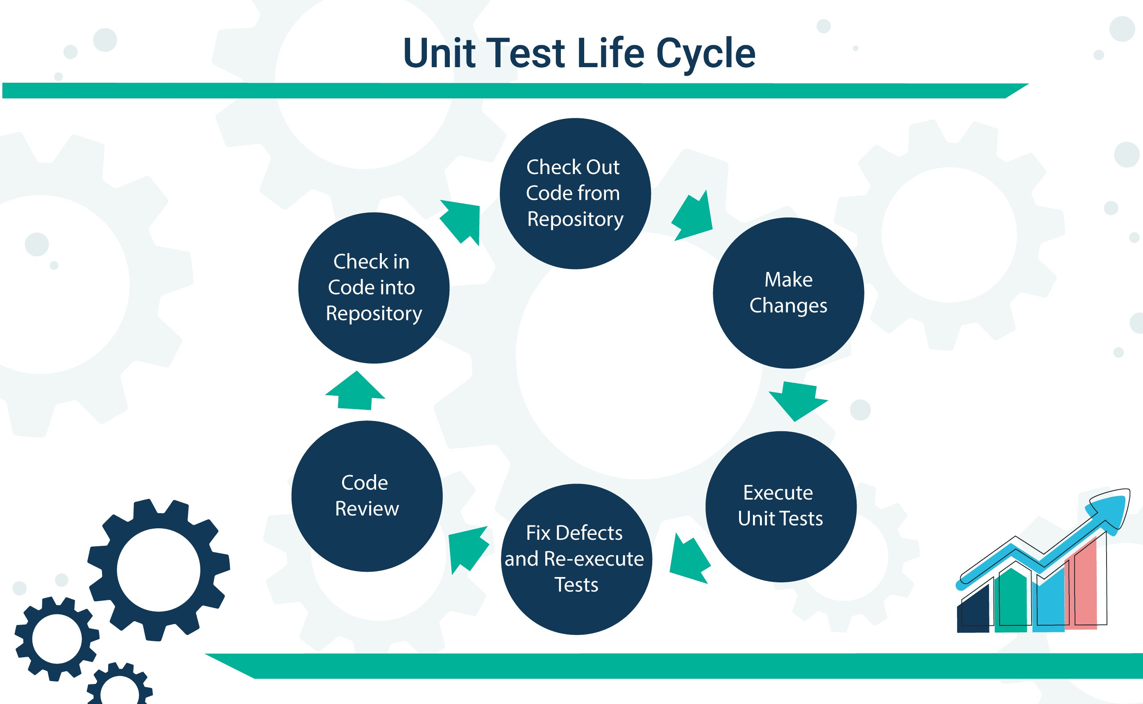

1. **Integration Testing:**

* Integration Testing is defined as the software modules are integrated logically and tested as a group.
* The purpose of this level of testing is to find defects in the interaction between these software modules when they are integrated
* It mainly focuses on checking data communication among these modules

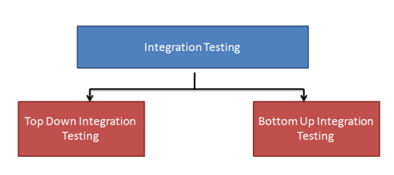

1. **Regression Testing:**

* In Regression Testing, it confirms that a recent program or code change has not affected existing features.
* It ensures that the new code changes should not have side effects on the existing functionalities
* It ensures that the old code still works once the latest code changes are done

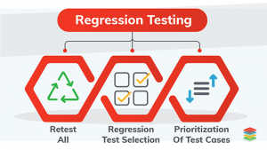

1. **Smoke Testing:**

* Smoke Testing  determines whether the deployed software build is stable or not
* Smoke Testing is done whenever the new functionalities of software are developed and integrated with existing build that is deployed
* It ensures that all critical functionalities are working correctly or not

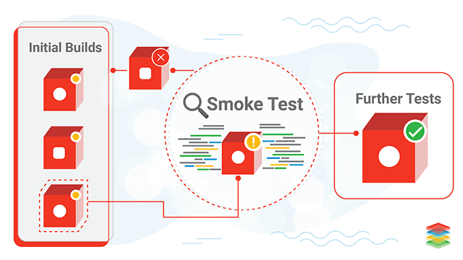

1. **Alpha Testing:**

* Alpha Testing is performed to identify bugs before releasing the software product to the real users or public
* The main objective is to refine the software product without any bugs that were not discovered through previous tests
* This testing is carried out near the end of the development of the software, and before Beta Testing.

1. **Beta Testing:**

* Beta Testing is performed by “real users” of the software application in “real environment” and it can be considered as a form of external [User Acceptance Testing](https://www.guru99.com/user-acceptance-testing.html).
* In this testing, Beta version of the software is released to a limited number of end-users of the product to obtain feedback on the product quality.
* This reduces product failure risks and provides increased quality of the product through customer validation.

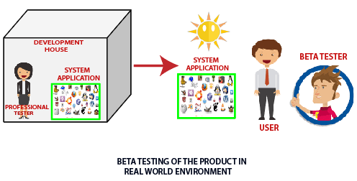

1. **System Testing:**

* System Testing is a level of testing that validates the complete and fully integrated software product
* The purpose of a system test is to evaluate the end-to-end system specifications
* System Testing is actually a series of different tests that are performed to evaluate that the product can be executed on different environments

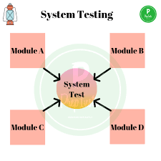

1. **Stress Testing:**

* Stress Testing is a type of software testing that verifies stability & reliability of software application.
* The goal of Stress testing is measuring software on its robustness and error handling capabilities under extremely heavy load conditions
* And while performing these extreme conditions, it ensures that software doesn’t crash under crunch situations

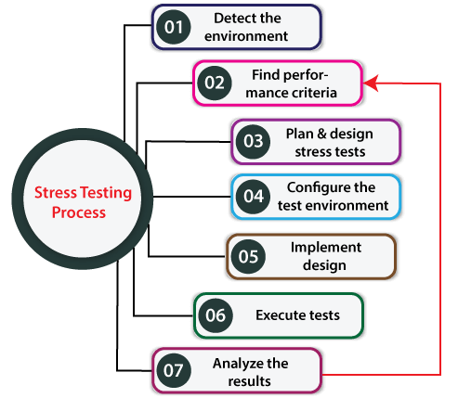

1. **Performance Testing:**

* Performance Testing is used for testing the several aspects like speed, response time, stability, reliability, scalability and resource usage of a software application
* The main purpose of performance testing is to identify and eliminate the performance bottlenecks in the software application

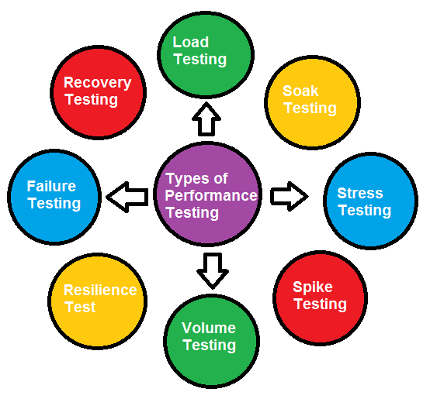

1. **Object Oriented Testing:**

This testing is a combination of various testing techniques that help to verify and validate object-oriented software. This testing is done in the following manner:

* Testing of Requirements
* Design and Analysis of Testing
* Testing of Code
* Integration testing
* System testing
* User Testing